Design Document

Course: 3584 – Advanced Web-Development
Group 15:
Akash Silas Nesakumar - 1751388
Nguyen Son Thien - 1751364
Avnish Jayprakash Raut - 1751366

Class Diagram
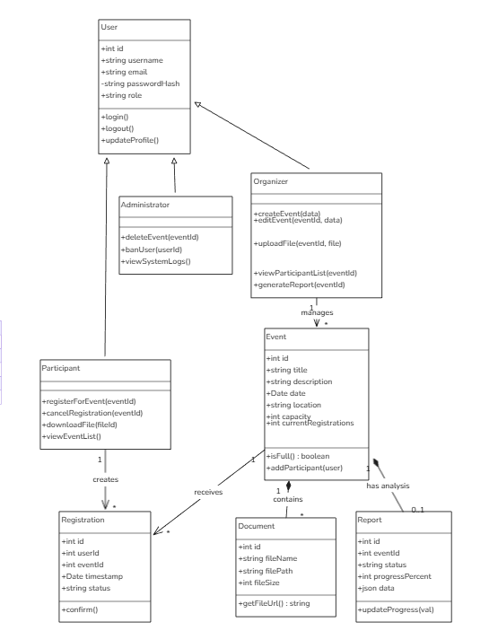

Sequence Diagram for Event Registration and Report Generation
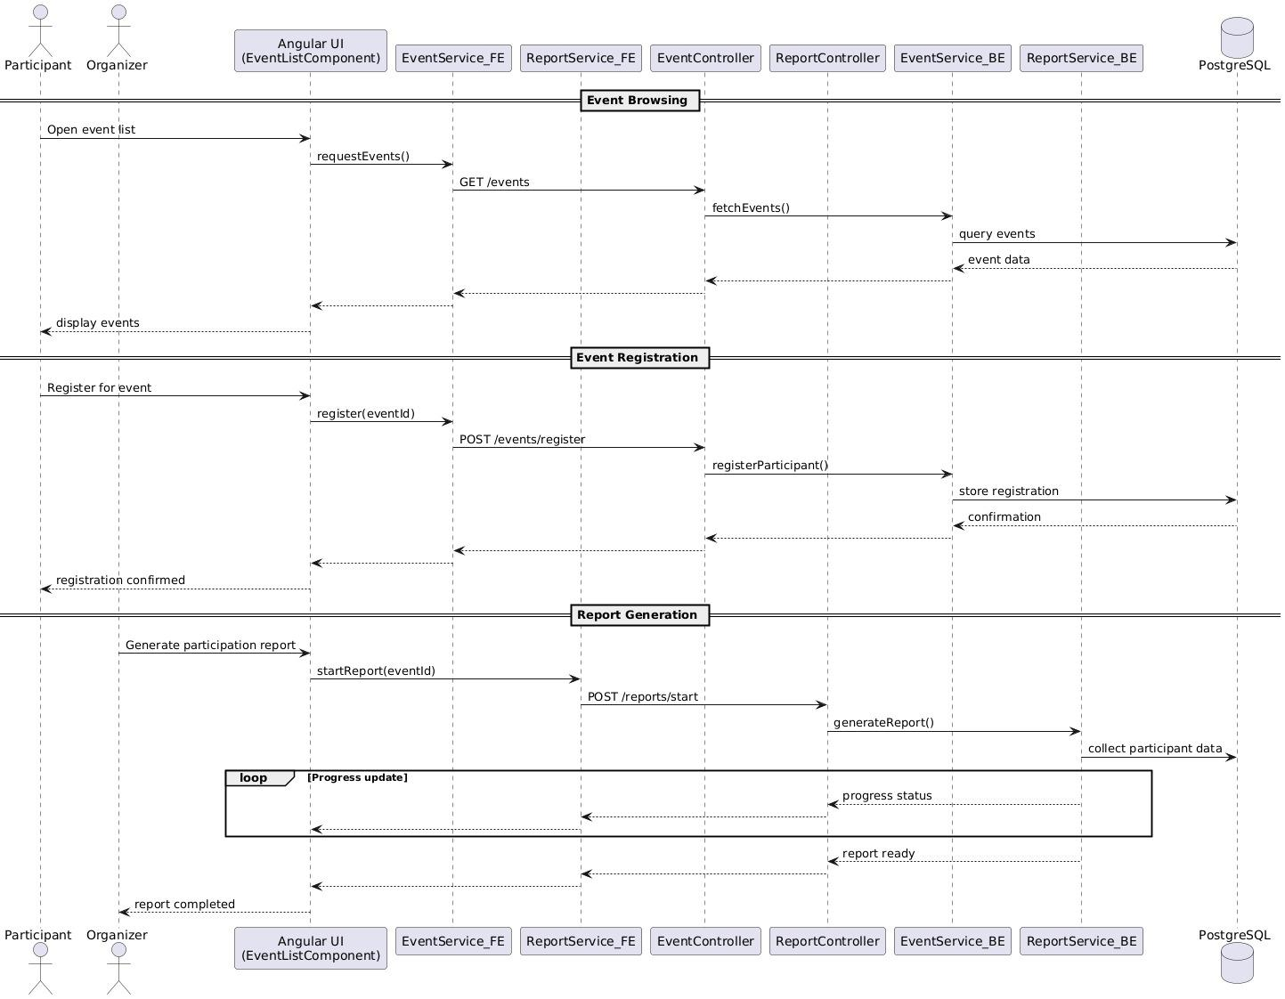

Use Case Diagram :
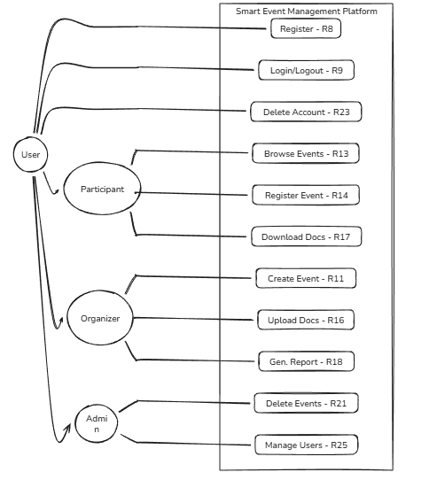

ERD Diagram
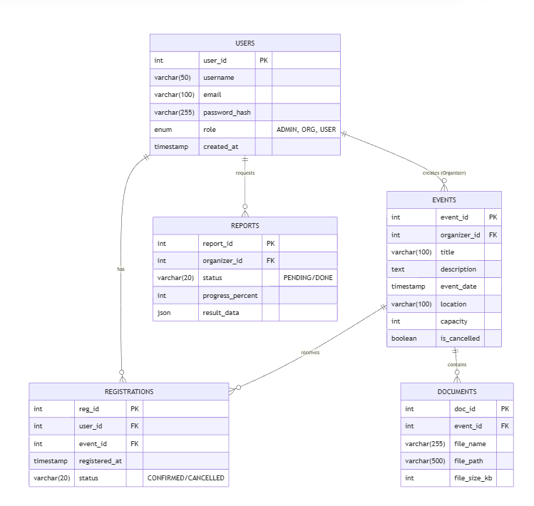

Angular Component
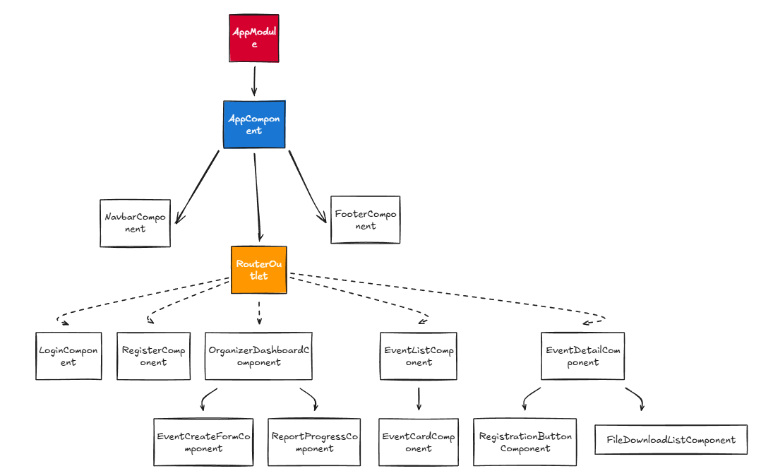

UI
Login System
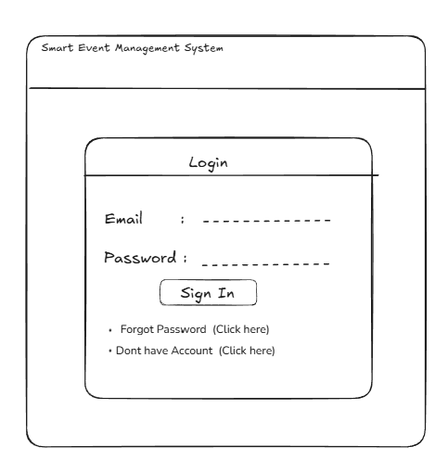

Organiser Dashboard
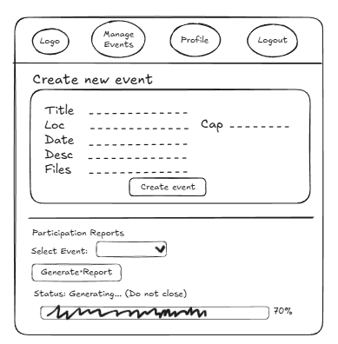

Event Dashboard
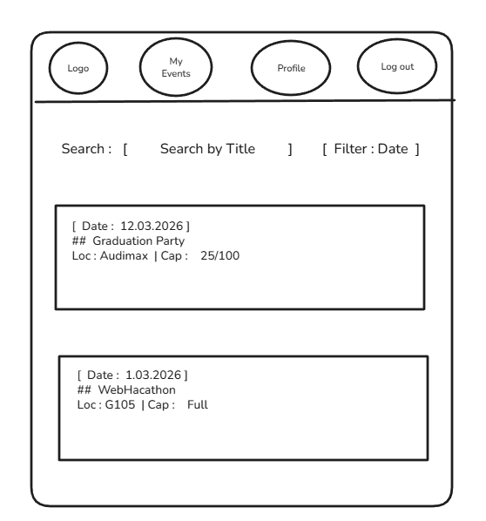

Event Registration
